**Build your own Arduino-Controlled Robot!**

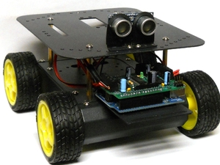

**User-Contributed Project**

This project guide is not managed by MAKE staff.

Learn how to build an Arduino-controlled robot from parts found in the Maker Shed!

* Author: [Nick Brenn](http://makeprojects.com/User/2518/Nick+Brenn)
* Time required: **A weekend at most!**
* Difficulty: **Moderate**

Robotics can be a difficult hobby to jump into, but the Arduino and the 4WD Robot Platform make it easy for you to build an awesome robot without a struggle! By utilizing components found in the [Maker Shed](http://www.makershed.com), this guide makes it easy for you to learn the basics of robotics, applications of the Arduino, and the process of building something awesome to show your family and friends.

Here is the code on [GitHub](https://gist.github.com/2354277)

**Sections**

* [Gather your Platform Parts](http://makeprojects.com/Project/Build+your+own+Arduino-Controlled+Robot%21/577/1#s3003)
* [Separate your Screws](http://makeprojects.com/Project/Build+your+own+Arduino-Controlled+Robot%21/577/1#s3004)
* [Attaching the Motors](http://makeprojects.com/Project/Build+your+own+Arduino-Controlled+Robot%21/577/1#s3005)
* [Wiring up the Motor](http://makeprojects.com/Project/Build+your+own+Arduino-Controlled+Robot%21/577/1#s3006)
* [Wire up your Toggle Switch](http://makeprojects.com/Project/Build+your+own+Arduino-Controlled+Robot%21/577/1#s3007)
* [Screwing in the Main Frame](http://makeprojects.com/Project/Build+your+own+Arduino-Controlled+Robot%21/577/1#s3008)
* [Attach the Bottom Cover](http://makeprojects.com/Project/Build+your+own+Arduino-Controlled+Robot%21/577/1#s3009)
* [Mounting the Battery Holder](http://makeprojects.com/Project/Build+your+own+Arduino-Controlled+Robot%21/577/1#s3010)
* [Wiring the Power Switch to the Battery Holder](http://makeprojects.com/Project/Build+your+own+Arduino-Controlled+Robot%21/577/2#s3011)
* [Add Batteries to Holder](http://makeprojects.com/Project/Build+your+own+Arduino-Controlled+Robot%21/577/2#s3016)
* [Add the Top Cover](http://makeprojects.com/Project/Build+your+own+Arduino-Controlled+Robot%21/577/2#s3017)
* [Solder the Motor Shield](http://makeprojects.com/Project/Build+your+own+Arduino-Controlled+Robot%21/577/2#s3018)
* [Resistors](http://makeprojects.com/Project/Build+your+own+Arduino-Controlled+Robot%21/577/2#s3019)
* [Yellow Capacitors](http://makeprojects.com/Project/Build+your+own+Arduino-Controlled+Robot%21/577/2#s3020)
* [Reset button and Resistor Network.](http://makeprojects.com/Project/Build+your+own+Arduino-Controlled+Robot%21/577/2#s3021)
* [IC Chips](http://makeprojects.com/Project/Build+your+own+Arduino-Controlled+Robot%21/577/2#s3022)
* [47uF Capacitors](http://makeprojects.com/Project/Build+your+own+Arduino-Controlled+Robot%21/577/3#s3023)
* [100uF Capcacitors](http://makeprojects.com/Project/Build+your+own+Arduino-Controlled+Robot%21/577/3#s3024)
* [Trim your Headers](http://makeprojects.com/Project/Build+your+own+Arduino-Controlled+Robot%21/577/3#s3025)
* [The Terminal Blocks](http://makeprojects.com/Project/Build+your+own+Arduino-Controlled+Robot%21/577/3#s3026)
* [Installing Arduino Software](http://makeprojects.com/Project/Build+your+own+Arduino-Controlled+Robot%21/577/3#s3028)
* [Connect Motor Power to Motor Shield](http://makeprojects.com/Project/Build+your+own+Arduino-Controlled+Robot%21/577/3#s3029)
* [Connecting the Motors to the Motor Shield](http://makeprojects.com/Project/Build+your+own+Arduino-Controlled+Robot%21/577/3#s3047)

**Sections (continued)**

* [Testing the Motors and MotorShield](http://makeprojects.com/Project/Build+your+own+Arduino-Controlled+Robot%21/577/4#s3048)
* [Add Upper-Level Standoffs](http://makeprojects.com/Project/Build+your+own+Arduino-Controlled+Robot%21/577/4#s3049)
* [Install Front Carriage](http://makeprojects.com/Project/Build+your+own+Arduino-Controlled+Robot%21/577/4#s3050)
* [Install Sensor Mounts](http://makeprojects.com/Project/Build+your+own+Arduino-Controlled+Robot%21/577/4#s3051)
* [Installing the Ping Sensor (Part 1)](http://makeprojects.com/Project/Build+your+own+Arduino-Controlled+Robot%21/577/4#s3052)
* [Installing the Ping Sensor (Part 2)](http://makeprojects.com/Project/Build+your+own+Arduino-Controlled+Robot%21/577/4#s3053)
* [Securing the Ping Sensor](http://makeprojects.com/Project/Build+your+own+Arduino-Controlled+Robot%21/577/4#s3089)
* [Building the Arduino Power Supply](http://makeprojects.com/Project/Build+your+own+Arduino-Controlled+Robot%21/577/4#s3090)
* [Programming](http://makeprojects.com/Project/Build+your+own+Arduino-Controlled+Robot%21/577/5#s3091)

**Files**

* [4WD_motor_test.pdf](http://make-documents.s3.amazonaws.com/n4y3reY6WnfYQcXr.pdf)
* [4wd_code_new.pdf](http://make-documents.s3.amazonaws.com/XXlXKITHejNwMWdo.pdf)

**Tools**

* [Screwdriver (Flat and Phillips)](http://makeprojects.com/Item/Screwdriver_%28Flat_and_Phillips%29)
* [Solder](http://www.radioshack.com/product/index.jsp?productId=2062719) [Buy it](http://www.radioshack.com/product/index.jsp?productId=2062719)
* [Soldering iron](http://www.radioshack.com/product/index.jsp?productId=3086619) [Buy it](http://www.radioshack.com/product/index.jsp?productId=3086619)

**Relevant Parts**

* [Arduino Uno](http://www.makershed.com/ProductDetails.asp?ProductCode=MKSP4) $34.99 [Buy it](http://www.makershed.com/ProductDetails.asp?ProductCode=MKSP4)
* [4WD Arduino Compatible Mobile Platform](http://www.makershed.com/ProductDetails.asp?ProductCode=MKSEEED8) [Buy it](http://www.makershed.com/ProductDetails.asp?ProductCode=MKSEEED8)
* [PING))) Ultrasonic Sensor](http://www.makershed.com/ProductDetails.asp?ProductCode=MKPX5) [Buy it](http://www.makershed.com/ProductDetails.asp?ProductCode=MKPX5)
* [MotorShield for Arduino Kit](http://www.makershed.com/ProductDetails.asp?ProductCode=MKAD7) [Buy it](http://www.makershed.com/ProductDetails.asp?ProductCode=MKAD7)
* [Batteries, AA](http://www.radioshack.com/product/index.jsp?productId=10809940&filterName=Type&filterValue=AA) (5) [Buy it](http://www.radioshack.com/product/index.jsp?productId=10809940&filterName=Type&filterValue=AA)
* View:
* [Single page](http://makeprojects.com/Project/Build+your+own+Arduino-Controlled+Robot%21/577/paginated/off)
* Formats:
* [PDF](http://makeprojects.com/GuidePDF/link/577/en)
* [XML](http://makeprojects.com/api/1.0/guide/577?type=xml)
* [Embed](http://makeprojects.com/Project/Build+your+own+Arduino-Controlled+Robot%21/577/1#embed)

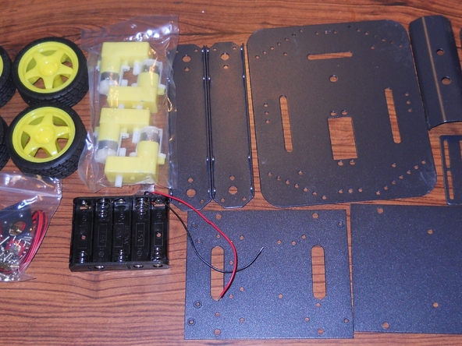

**[Add Note](http://makeprojects.com/Project/Build+your+own+Arduino-Controlled+Robot%21/577/1#addNote)**[**Edit**](http://makeprojects.com/Project/edit/577/3003) **Step 1 — Gather your Platform Parts**

* Open up the bag of parts for the mobile platform. You'll notice that there are no instructions included, so I will help to guide you through the build process.

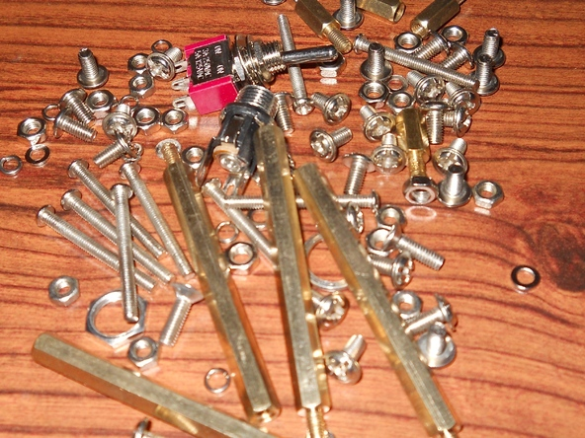

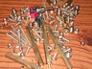

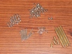

**[Add Note](http://makeprojects.com/Project/Build+your+own+Arduino-Controlled+Robot%21/577/1#addNote)**[**Edit**](http://makeprojects.com/Project/edit/577/3004) **Step 2 — Separate your Screws**

* Open up the small plastic bag, and take out all of the metal screws, and separate the screws that are alike.
* Separate the washers and the nuts as well. By isolating everything, it helps you to figure out where they end up being used.

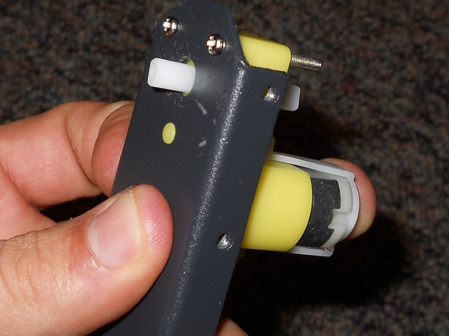

**[Add Note](http://makeprojects.com/Project/Build+your+own+Arduino-Controlled+Robot%21/577/1#addNote)**[**Edit**](http://makeprojects.com/Project/edit/577/3005) **Step 3 — Attaching the Motors**

* Find the two narrow metal pieces, and gather your motors. There is a small yellow hole on the motor, and a hole for the axle.
* Take one of the longer screws, and push it through from the outside of the metal, into the holes on the motor. The smaller washers and the smaller nuts will go with the longer screws.
* Do this for each motor.
* You will probably have extra screws or parts with the project, so don't get worried if you find extras.

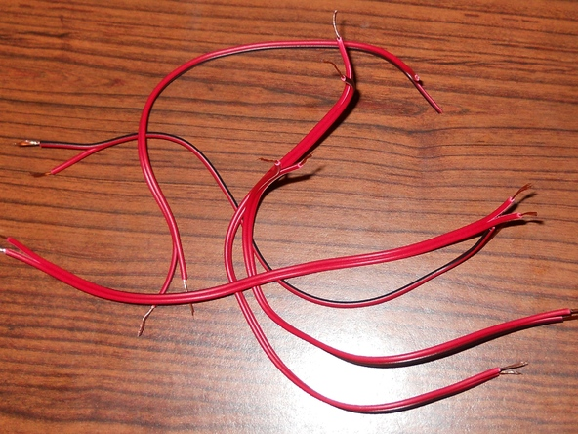

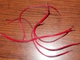

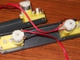

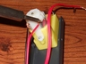

**[Add Note](http://makeprojects.com/Project/Build+your+own+Arduino-Controlled+Robot%21/577/1#addNote)**[**Edit**](http://makeprojects.com/Project/edit/577/3006) **Step 4 — Wiring up the Motor**

* Find the long strand of wire from your stash of parts. Cut five equal strands of this wire, and strip the ends of each side.
* Four strands will be used for the four motors, while the fifth will be used for the switch.
* Connect the two leads of the hookup wire to each of the leads on the motor. Take a soldering iron and solder the wires to the leads on the motor. Do this for each motor.
* Go into your Minitronics: Survival Packs and get a 0.1uf capacitor from each. They are labeled with a 104. After some research, I discovered that having a 0.1uf capacitor soldered across each lead on the motor will make sure they do not move at random intervals. So, just insert a capacitor into each motor lead as shown in the picture.
* Make sure that you are careful when soldering with the motors. The leads on the motor are fragile, so just be careful when attaching the wires to solder.

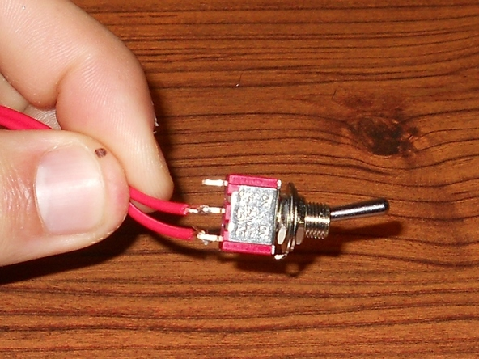

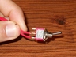

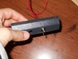

**[Add Note](http://makeprojects.com/Project/Build+your+own+Arduino-Controlled+Robot%21/577/1#addNote)**[**Edit**](http://makeprojects.com/Project/edit/577/3007) **Step 5 — Wire up your Toggle Switch**

* Attach the remaining piece of hookup wire to two consecutive leads on the toggle switch.
* Now find the half of the hexagonal metal piece with the two holes in the middle. Remove the nut and washer and place the toggle switch through the hole. Replace the nut and washer.

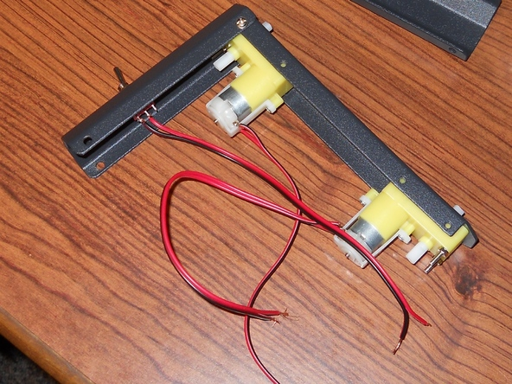

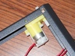

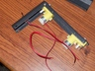

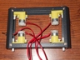

**[Add Note](http://makeprojects.com/Project/Build+your+own+Arduino-Controlled+Robot%21/577/1#addNote)**[**Edit**](http://makeprojects.com/Project/edit/577/3008) **Step 6 — Screwing in the Main Frame**

* Now gather eight of the smaller screws, and gather your octagonal metal pieces. The pieces should fit right together, and the holes on the edges should line up for the screws to fit into.
* Inert a screw on each side, and then insert the screws all the way around until you have a rectangular main frame for your platform.

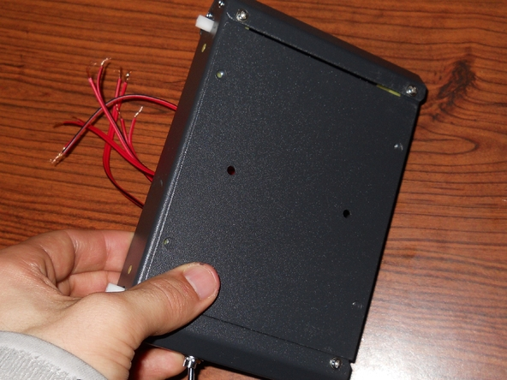

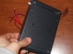

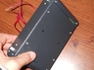

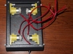

**[Add Note](http://makeprojects.com/Project/Build+your+own+Arduino-Controlled+Robot%21/577/1#addNote)**[**Edit**](http://makeprojects.com/Project/edit/577/3009) **Step 7 — Attach the Bottom Cover**

* Find the rectangular cover with six holes in it, with four on the edges.
* Place it over one side of the main frame and screw four screws into the holes that matched up. Note: the two remaining holes will be used for the battery holder.

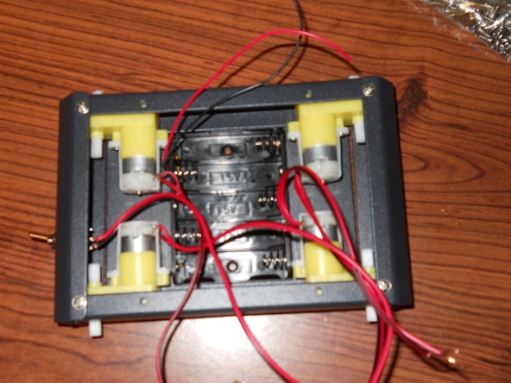

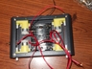

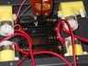

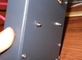

**[Add Note](http://makeprojects.com/Project/Build+your+own+Arduino-Controlled+Robot%21/577/1#addNote)**[**Edit**](http://makeprojects.com/Project/edit/577/3010) **Step 8 — Mounting the Battery Holder**

* The battery holder should be placed inside of the main frame, with the two wires of the battery holder facing the two wires of the toggle switch.
* Insert the two flathead screws that came in the original pack of screws. Push them through the holes in the battery holder and then place a nut and a washer on the other end.
* Don't screw them in too tight, because you do not want to crack the plastic battery holder.

Page 2 of 5

* [View large](http://guide-images.makeprojects.org/igi/HZkKgmFTI6wZQOea.large)
* [Image metadata](http://makeprojects.com/Project/Image/meta/HZkKgmFTI6wZQOea)

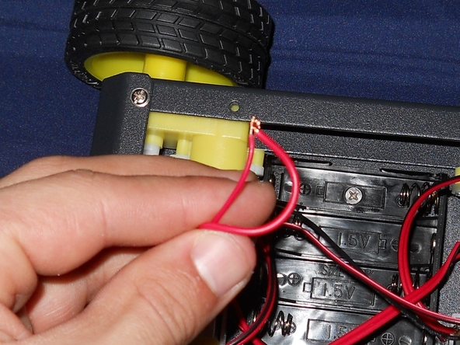

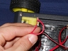

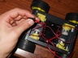

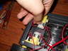

**[Add Note](http://makeprojects.com/Project/Build+your+own+Arduino-Controlled+Robot%21/577/2#addNote)**[**Edit**](http://makeprojects.com/Project/edit/577/3011) **Step 9 — Wiring the Power Switch to the Battery Holder**

* Connect the red wire from the battery holder to the middle wire on the toggle switch. Strip the black wire (if it's not already stripped) and leave it for now. The same goes for the remaining wire on the toggle switch.
* I recommend twisting the wires together, soldering them, and then putting some electrical tape over the connections.
* Then just hide the wires inside the frame.
* [View huge](http://guide-images.makeprojects.org/igi/McClOCRNJuACsw1I.huge)
* [Image metadata](http://makeprojects.com/Project/Image/meta/McClOCRNJuACsw1I)

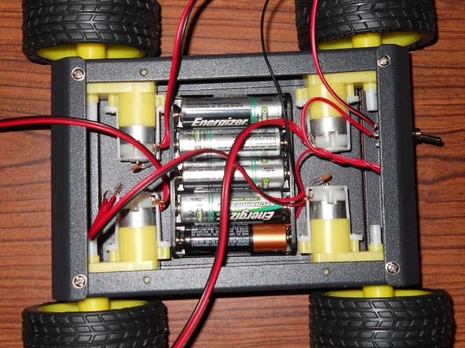

**[Add Note](http://makeprojects.com/Project/Build+your+own+Arduino-Controlled+Robot%21/577/2#addNote)**[**Edit**](http://makeprojects.com/Project/edit/577/3016) **Step 10 — Add Batteries to Holder**

* Since a cover will be going over the main frame, you will want to put the batteries in before we screw on the cover. You will need five AA batteries.

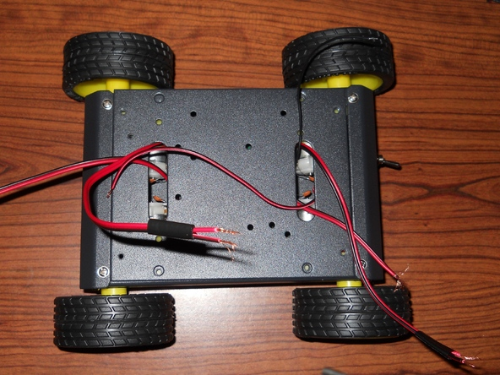

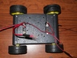

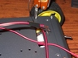

**[Add Note](http://makeprojects.com/Project/Build+your+own+Arduino-Controlled+Robot%21/577/2#addNote)**[**Edit**](http://makeprojects.com/Project/edit/577/3017) **Step 11 — Add the Top Cover**

* Find your top cover and place the side that has the 4 holes opposite to the toggle switch. This will be the front of the robot.
* String the wires through the slots that are on both ends of the cover. I denoted one side of the motors with some electrical tape, as it will help us when we wire the motors.
* Find 4 of the same type of screw that we have been using. Place the four screws through the 4 holes that you can see are open. Refer to the image if you need to know where exactly to screw it in.
* [View huge](http://guide-images.makeprojects.org/igi/YU3cJMOTXoNNRedY.huge)
* [Image metadata](http://makeprojects.com/Project/Image/meta/YU3cJMOTXoNNRedY)

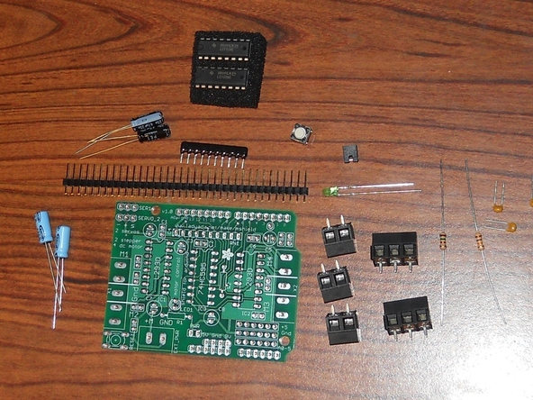

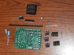

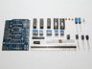

**[Add Note](http://makeprojects.com/Project/Build+your+own+Arduino-Controlled+Robot%21/577/2#addNote)**[**Edit**](http://makeprojects.com/Project/edit/577/3018) **Step 12 — Solder the Motor Shield**

* Now that the main chassis of the robot is built, we can get started on some of the electrical! The Arduino Motor Shield makes it easy to control and power your motors.
* Find your Motor Shield kit and components, and let's get started!
* [View large](http://guide-images.makeprojects.org/igi/r6ZnBTOfOS1xD3LV.large)
* [Image metadata](http://makeprojects.com/Project/Image/meta/r6ZnBTOfOS1xD3LV)

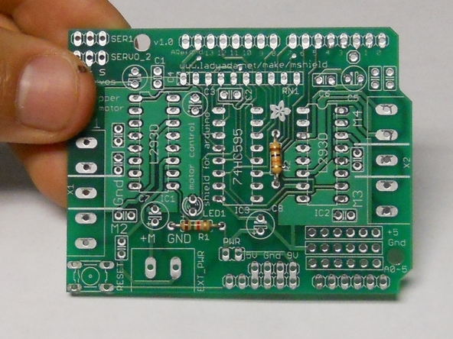

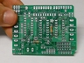

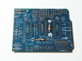

**[Add Note](http://makeprojects.com/Project/Build+your+own+Arduino-Controlled+Robot%21/577/2#addNote)**[**Edit**](http://makeprojects.com/Project/edit/577/3019) **Step 13 — Resistors**

* Insert the Brown-Green-Red resistor into R1, and the Brown-Black-Orange into R2.

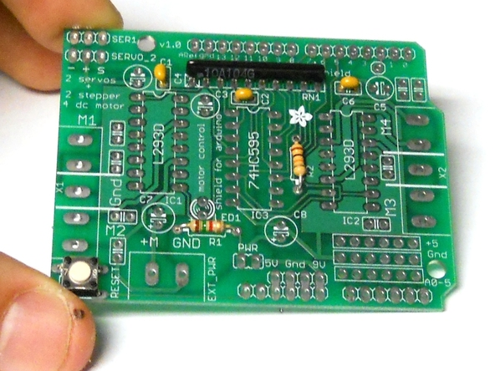

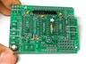

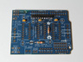

**[Add Note](http://makeprojects.com/Project/Build+your+own+Arduino-Controlled+Robot%21/577/2#addNote)**[**Edit**](http://makeprojects.com/Project/edit/577/3020) **Step 14 — Yellow Capacitors**

* Insert the yellow ceramic capacitors into C4, C2, and C6. Then solder these in.
* (I had a blurry image for this step, so I am using the image from the next step in this step as well.) The next two components will be described in the next step.
* [View large](http://guide-images.makeprojects.org/igi/Ze3Alc14Ni1TrMiN.large)
* [Image metadata](http://makeprojects.com/Project/Image/meta/Ze3Alc14Ni1TrMiN)





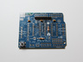

**[Add Note](http://makeprojects.com/Project/Build+your+own+Arduino-Controlled+Robot%21/577/2#addNote)**[**Edit**](http://makeprojects.com/Project/edit/577/3021) **Step 15 — Reset button and Resistor Network.**

* The Reset button goes into the bottom left. The resistor network is inserted where it says RN1. Make sure the end with the dot goes into the hole marked with the X.
* [View huge](http://guide-images.makeprojects.org/igi/PidUTKAoqwHURhit.huge)
* [Image metadata](http://makeprojects.com/Project/Image/meta/PidUTKAoqwHURhit)

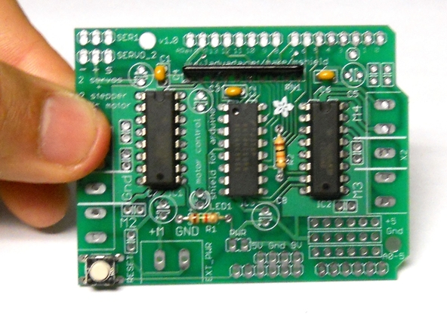

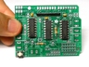

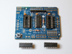

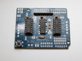

**[Add Note](http://makeprojects.com/Project/Build+your+own+Arduino-Controlled+Robot%21/577/2#addNote)**[**Edit**](http://makeprojects.com/Project/edit/577/3022) **Step 16 — IC Chips**

* There are two L293D IC chips. Insert them into IC1 and IC2. Then insert the other IC, the 74HC595, into IC3. Make sure the indented U on the IC matches up with the U on the circuit board.

Page 3 of 5

* [View huge](http://guide-images.makeprojects.org/igi/PJDX4FwRgUjKtoKc.huge)
* [Image metadata](http://makeprojects.com/Project/Image/meta/PJDX4FwRgUjKtoKc)

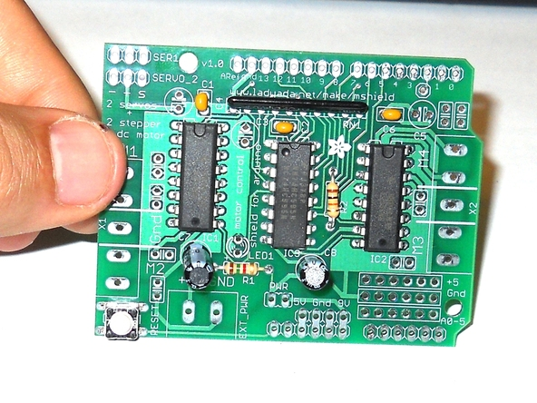

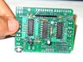

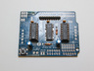

**[Add Note](http://makeprojects.com/Project/Build+your+own+Arduino-Controlled+Robot%21/577/3#addNote)**[**Edit**](http://makeprojects.com/Project/edit/577/3023) **Step 17 — 47uF Capacitors**

* There are two black 47uF capacitors that are included in the kit. These will be inserted into C7 and C8. Make sure you insert them with the correct polarity. The negative side is noted with a gray strip, so insert that in the hole that is not noted positive on the circuit board.
* [View large](http://guide-images.makeprojects.org/igi/cSIHXAPZPhl1PXeo.large)
* [Image metadata](http://makeprojects.com/Project/Image/meta/cSIHXAPZPhl1PXeo)

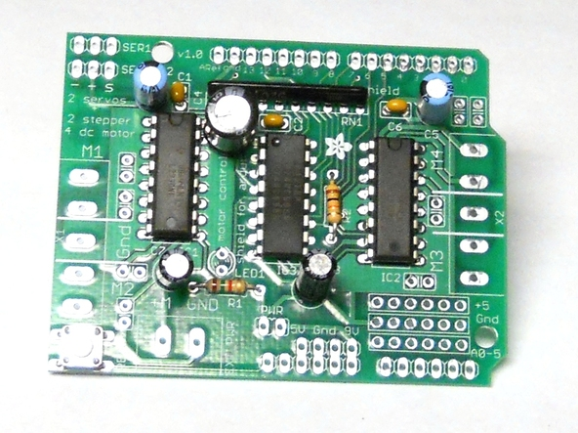

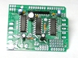

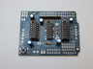

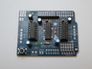

**[Add Note](http://makeprojects.com/Project/Build+your+own+Arduino-Controlled+Robot%21/577/3#addNote)**[**Edit**](http://makeprojects.com/Project/edit/577/3024) **Step 18 — 100uF Capcacitors**

* There are three 100uF capacitors included in the kit. Just as with the other capacitors, note the polarity when you insert them. I only had two 100uF capacitors included in my kit, but in my Minitronics: Survival Pack there was a 100uF capacitor. It had a higher voltage rating than the others, but that is fine. Solder these in.
* While you are at it, insert the LED into its spot, labeled LED1. The longer lead is the positive lead, so note this when you are inserting it into the circuit board. Solder it in.
* [View large](http://guide-images.makeprojects.org/igi/kKrAL1ihgAlPv1VG.large)
* [Image metadata](http://makeprojects.com/Project/Image/meta/kKrAL1ihgAlPv1VG)

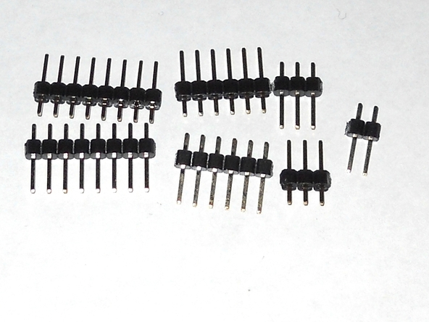

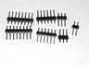

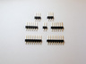

**[Add Note](http://makeprojects.com/Project/Build+your+own+Arduino-Controlled+Robot%21/577/3#addNote)**[**Edit**](http://makeprojects.com/Project/edit/577/3025) **Step 19 — Trim your Headers**

* Included is a 36-pin header. Snip the header into two 8-pin headers, two 6-pin headers, two 3-pin headers, and one 2-pin header.
* The two 3-pin headers will be inserted into the top left of the circuit board. The shorter side is inserted into the board, so keep the longer leads up.
* The 2-pin header will be inserted into the holes labeled PWR. As before, shorter side in, longer side out. Keep the 6-pin and 8-pin headers for a later step.
* [View large](http://guide-images.makeprojects.org/igi/bjjPDaOqFMMWTJQd.large)
* [Image metadata](http://makeprojects.com/Project/Image/meta/bjjPDaOqFMMWTJQd)

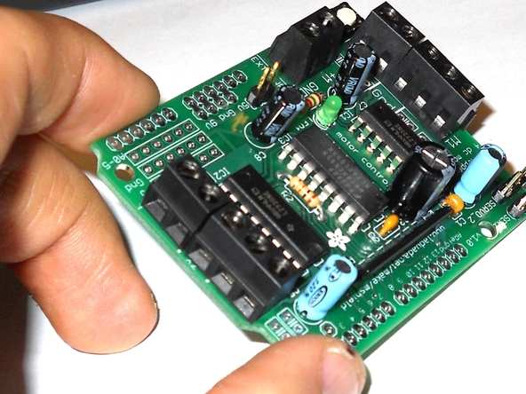

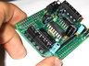

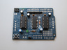

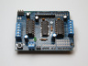

**[Add Note](http://makeprojects.com/Project/Build+your+own+Arduino-Controlled+Robot%21/577/3#addNote)**[**Edit**](http://makeprojects.com/Project/edit/577/3026) **Step 20 — The Terminal Blocks**

* There are three 2-terminal blocks and two 3-terminal blocks. One of the 2-terminal blocks is inserted into the EXT_PWR space.
* On each side of the circuit board, there are terminals with 5 spots. So on each side, just combine a 2-terminal block and a 3-terminal block. Solder these in with the square openings facing outward. This is where the wires are connected into.
* Ignore soldered in pins (headers) in on the Msheild v1.1. This can be done last, after the arduino and shield have been connected. Though, If you prefer you can do it now.
* [View large](http://guide-images.makeprojects.org/igi/4KVg3jEXHhKvNaFy.large)
* [Image metadata](http://makeprojects.com/Project/Image/meta/4KVg3jEXHhKvNaFy)

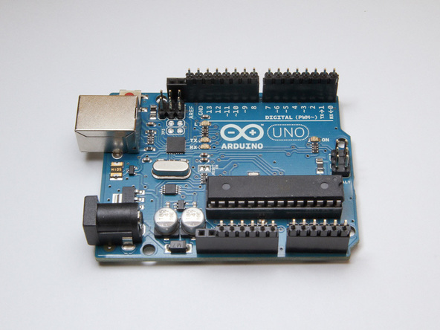

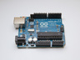

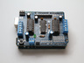

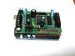

**[Add Note](http://makeprojects.com/Project/Build+your+own+Arduino-Controlled+Robot%21/577/3#addNote)**[**Edit**](http://makeprojects.com/Project/edit/577/3027) **Step 21**

* The remaining headers
* Now take the remaining headers and place them in your Arduino, with the small ends facing upward.
* Now place the Motor Shield over the headers connected to the Arduino, and poke the short leads through the holes in the shield.
* Now solder the joints. Once these are soldered, you are ready to go. The Motor Shield can be removed, or kept on for now.
* If using the uno, note how there are some pins (headers) not placed in the arduino, this is important.
* [View huge](http://guide-images.makeprojects.org/igi/TY3U4JfTEdVowEEZ.huge)
* [Image metadata](http://makeprojects.com/Project/Image/meta/TY3U4JfTEdVowEEZ)

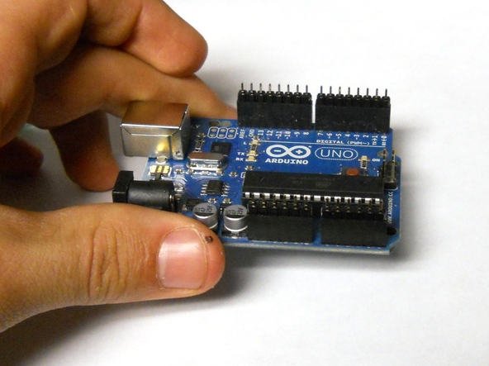

**[Add Note](http://makeprojects.com/Project/Build+your+own+Arduino-Controlled+Robot%21/577/3#addNote)**[**Edit**](http://makeprojects.com/Project/edit/577/3028) **Step 22 — Installing Arduino Software**

* Install your Arduino Software if you haven't done so. Check out the [Make: How-To Tuesday tutorial](http://blog.makezine.com/archive/2009/02/howto-tuesday-arduino-101-blink-an.html) to help you set up your Arduino.

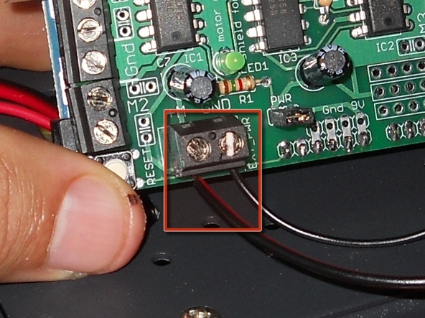

**[Add Note](http://makeprojects.com/Project/Build+your+own+Arduino-Controlled+Robot%21/577/3#addNote)**[**Edit**](http://makeprojects.com/Project/edit/577/3029) **Step 23 — Connect Motor Power to Motor Shield**

* Find the remaining lead from the toggle switch, and the black lead from the battery holder.
* Unscrew the screws on the terminal block with the 2 terminals. Now take the black lead and insert it into the GND terminal. Take the lead from the toggle switch and insert it into the M+ terminal.
* Tighten up the screws for the terminal, and your Arduino should receive power now. Hit the switch to make sure it turns on.
* [View huge](http://guide-images.makeprojects.org/igi/MnZl3cIfXGkrnWPy.huge)
* [Image metadata](http://makeprojects.com/Project/Image/meta/MnZl3cIfXGkrnWPy)

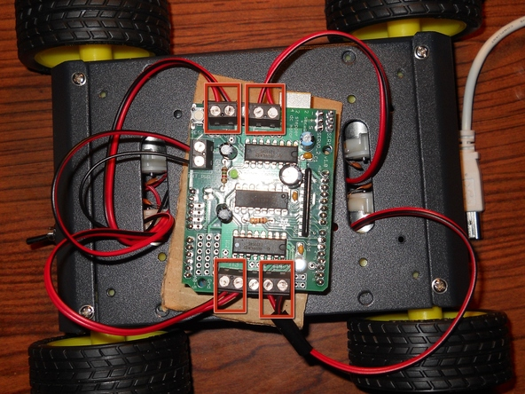

**[Add Note](http://makeprojects.com/Project/Build+your+own+Arduino-Controlled+Robot%21/577/3#addNote)**[**Edit**](http://makeprojects.com/Project/edit/577/3047) **Step 24 — Connecting the Motors to the Motor Shield**

* Take the wires that are coming from your motors and insert each set of the wires into the two outer terminals (in the row of 5).
* Polarity does not matter at this point. When you get the motors running, if you discover that the wheel on a motor needs to rotate in the opposite direction just switch the wires that you inserted into the terminal.
* All right; we have reached Checkpoint #1 and now we can test to make sure your motors and Arduino are working. We'll test these in the next step.

**Step 25 — Testing the Motors and MotorShield**

* Start by hitting the toggle switch. If the green light goes on, that means there is power to the Motor Shield, which means power to your motors!
* Now we can go ahead and test the Motor Shield. Assuming that your computer has the Arduino program installed, we can move on.
* Connect the Arduino to your computer, and upload the Motor_Test.pdf sketch found at the beginning of the project. This is just a simple loop to make sure your motors are working.
* Make sure your Arduino is not touching the metal surface of the chassis. I didn't realize this at the beginning, so my motors were just twitching randomly! So place a piece of cardboard underneath the Arduino to make sure nothing is being shorted out. You can paint the cardboard black so that it matches the chassis color.

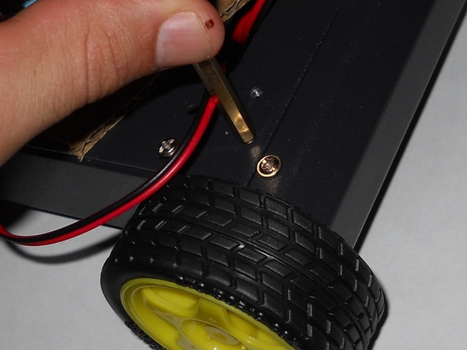

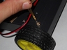

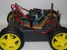

**[Add Note](http://makeprojects.com/Project/Build+your+own+Arduino-Controlled+Robot%21/577/4#addNote)**[**Edit**](http://makeprojects.com/Project/edit/577/3049) **Step 26 — Add Upper-Level Standoffs**

* Screw in the long, bronze-colored standoffs into the screw holes that are between the pairs of screws on the chassis.
* Then you can add the upper level of the frame. This can be used for the Ping sensor or your choice of other accessories. The improvisation is up to you.

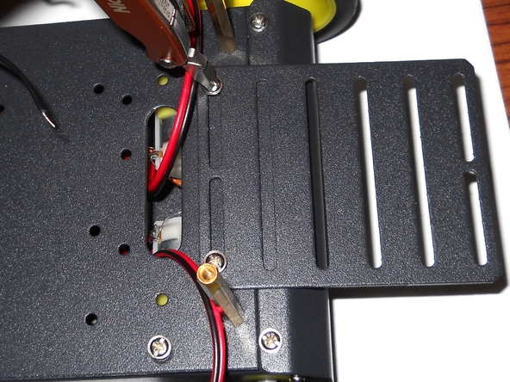

**[Add Note](http://makeprojects.com/Project/Build+your+own+Arduino-Controlled+Robot%21/577/4#addNote)**[**Edit**](http://makeprojects.com/Project/edit/577/3050) **Step 27 — Install Front Carriage**

* The remaining metal piece that hasn't been installed yet is the piece with the multiple narrow slits.
* On the end opposite to the toggle switch, there are two extra holes, where you can screw in the front carriage.
* I'll be putting the Arduino here, but it is your choice.

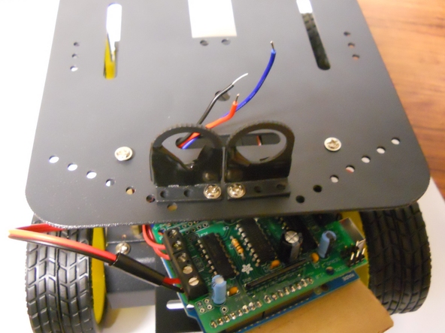

**[Add Note](http://makeprojects.com/Project/Build+your+own+Arduino-Controlled+Robot%21/577/4#addNote)**[**Edit**](http://makeprojects.com/Project/edit/577/3051) **Step 28 — Install Sensor Mounts**

* In the bag of the screws there are three weird-looking metal pieces with a hole in each of them. I'll be using two of these to hold up the Ping sensor on the upper level of the robot.
* Begin by wrapping the metal thoroughly in electrical tape. The sensor will be pretty close to the metal, so you don't want any shorts occurring.
* I used just one screw for each piece, but since there are only 3 holes, it has to be slightly off to one side or the other.
* It may be easier to remove the upper level to screw these pieces in. It is tough to get the nuts onto the screws when the upper-level frame is attached.

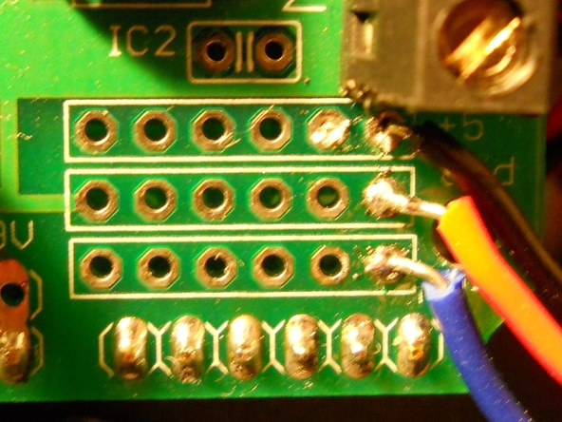

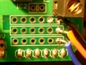

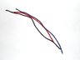

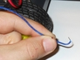

**[Add Note](http://makeprojects.com/Project/Build+your+own+Arduino-Controlled+Robot%21/577/4#addNote)**[**Edit**](http://makeprojects.com/Project/edit/577/3052) **Step 29 — Installing the Ping Sensor (Part 1)**

* You are going to be connecting the Ping sensor to the Motor Shield. On the Motor Shield you will see 3 rows, each with 6 holes. They are marked GND, +5, and A0-5.
* Go into your Minitronics Survival Pack and take out the replacement hookup wires. Cut off three pieces (I used different colors), each of a length that can go from the front carriage to the top level. If you are in doubt, just cut it longer than you think you need.
* Strip both ends of each wire. Now, take one end of the first wire and insert it from the bottom up into one of the holes in A0-5. Solder this wire in from the top.
* The A0-5 holes go to the analog inputs on the Arduino, but these can also be used as digital inputs if specified in the program (which it will be).
* Take the second piece of wire and insert it (from the bottom up) into one hole in the GND row. Solder it in from the top.
* Finally, take your last piece of wire and insert it (from the bottom up) into a hole in the 5+ row. Solder this in.

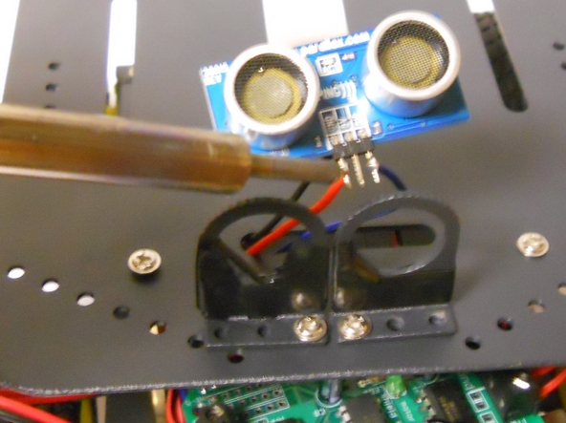

**[Add Note](http://makeprojects.com/Project/Build+your+own+Arduino-Controlled+Robot%21/577/4#addNote)**[**Edit**](http://makeprojects.com/Project/edit/577/3053) **Step 30 — Installing the Ping Sensor (Part 2)**

* Now poke the three wires through the narrow slit that is at the front of the robot. They connect to the PING sensor itself.
* Solder each wire, being careful that the GND from the shield is soldered to the GND on the sensor. The 5+ on the shield connects to the 5+ pin on the sensor, and the A0-5 on the shield connects to the SIG pin on the sensor.
* Wrap your hookup wire around each sensor lead carefully, and solder them.

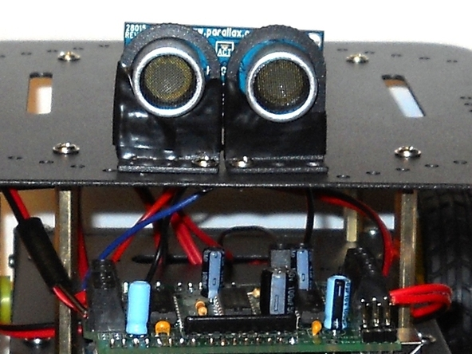

**[Add Note](http://makeprojects.com/Project/Build+your+own+Arduino-Controlled+Robot%21/577/4#addNote)**[**Edit**](http://makeprojects.com/Project/edit/577/3089) **Step 31 — Securing the Ping Sensor**

* Now you are ready to secure the Ping sensor to the sensor mounts. I wrapped the sensor mounts with electrical tape to make the Ping sensor stay in better.
* Make sure no wires or metal from the sensor is touching any other metal. If it is, just wrap the culprit in a small piece of electrical tape.

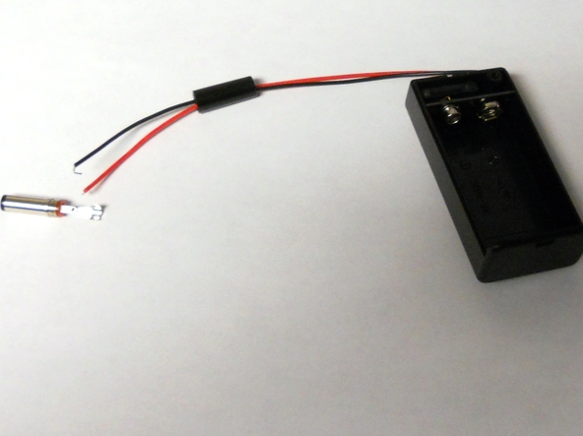

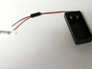

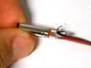

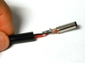

**[Add Note](http://makeprojects.com/Project/Build+your+own+Arduino-Controlled+Robot%21/577/4#addNote)**[**Edit**](http://makeprojects.com/Project/edit/577/3090) **Step 32 — Building the Arduino Power Supply**

* Find your 9V Battery holder, the battery holder plug, and the screw that holds it all together.
* Unscrew the plastic piece from the plug and slide it up the two wires towards the case. It will be screwed on top of the plug once the wires are soldered.
* The red wire from the holder is to be connected to the shorter lead on the plug while the black wire is soldered to the longer lead.
* Crimp the two wires in the strain relief making sure that they do not short together. Then take the plastic housing and screw it over the metal plug.
* Install a battery into the holder. Screw in the screw to hold the case together, and we are ready to go.

### Step 33 — Programming

* I have provided a program that you can load onto your Arduino. It is in a file called Arduino_Robot_Code.pdf found under the "Files" section on the first page of this guide. This program makes the robot move forward until an object is located. The robot then moves backward and turns right. Then it goes forward again, repeating this process.
* Plug the Arduino into the USB port on your computer. The 9V battery plug connects to the black female connector on the Arduino.
* Compile the code, and then upload the code to the Arduino.
* Hit the switch on the back of your robot, hit the switch on the battery supply, and you have an object-avoiding Arduino-powered robot!